Provided services

**General dentistry**: General dentistry **covers a range of treatment options and procedures fundamental to protecting and maintaining a good standard of oral health**. Treatments are in place to keep your mouth, gums, and teeth healthy and free of pain

**Preventive Orthodontics:** The goal of this treatment is to keep malocclusions or ‘bad bites’ from developing.

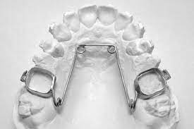

1. **Interceptive orthodontics:** Interceptive treatment is necessary to avoid the development of problems that could possibly lead to severe dental cases. Its objective is to address a developing problem to reduce the length and extensiveness of later orthodontic treatment.

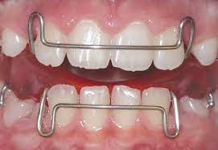

**Corrective orthodontics: Corrective orthodontics is the treatment of a malocclusion in the permanent dentition. ( put a photo with braces)**

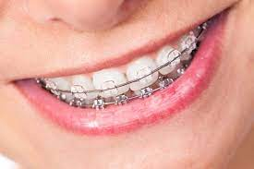

**Periodontal treatment:** The goal of periodontitis treatment is to **thoroughly clean the pockets around teeth and prevent damage to surrounding bone**.

Fixed and removable dentures:

**Fixed dentures:** Also know as non-removable dentures – stays in your mouth at all times are basically **denture devices that are fixed and cannot be removed by the patient is only at the dental office where this can be fix and remove.**

**Removable dentures:** Removable dentures usually consist of replacement teeth attached to pink or gum-colored plastic or metal bases. Depending on your needs, the dentist will design a partial denture or full denture for you.

Oral surgeries: are **any surgical procedure performed on your teeth, gums, jaws or other oral structures**. This includes extractions, implants, gum grafts and other procedures.

**Restorations**: Restorations are the various ways your dentist can replace or restore your missing teeth or missing parts of your tooth structure, or structures that need to be removed to prevent decay that may cause you pain in the future

The common restauration is A filling this is **used to treat a small hole, or cavity, in a tooth**. To repair a cavity, a dentist removes the decayed tooth tissue and then fills the space with a filling material.

Cosmetic dentistry: Cosmetic dentistry is **the medical improvement of the overall appearance of your teeth**– resulting in a great smile. Although this area of dentistry is elective and not essential, repairing your teeth's appearance can have many benefits on your oral health as well.

ROOT CANAL TREATMENTS Root canal treatment (endodontics) is **a dental procedure used to treat infection at the center of a tooth**. Root canal treatment is not painful and can save a tooth that might otherwise have to be removed completely.

Dental imagenology: A periapical x-ray is **one that captures the whole tooth**. It shows everything from the crown (chewing surface) to the root (below the gum line). Each periapical x-ray shows a small section of your upper or lower teeth. These x-rays are often used to detect any unusual changes in the root and surrounding bone structures.